**Lab Report No. 6**



**Digital Signal Processing**

**Submitted By:** Maaz Habib

**Registration No:** 20pwcse1952

**Section:** C

“On my honor, as student of University of Engineering and Technology, I have neither given nor received unauthorized assistance on this academic work”

**Department of Computer Systems Engineering**

**University of Engineering and Technology Peshawar**

**CSE 402L: Digital Signal Processing**

|  |  |  |  |  |
| --- | --- | --- | --- | --- |
| **Demonstration of Concepts** | **Poor (Does not meet expectation (1))**  The student failed to demonstrate a clear understanding of the assignment concepts | **Fair (Meet Expectation (2-3))**  The student demonstrated a clear understanding of some of the assignment concepts | **Good (Exceeds Expectation (4-5)**  The student demonstrated a clear understanding of the assignment concepts | **Score**  **30%** |
| **Accuracy** | The student completed (<50%) tasks and provided MATLAB code and/or Simulink models with errors. Outputs shown are not correct in form of graphs (no labels) and/or tables along with incorrect analysis or remarks. | The student completed partial tasks (50% - <90%) with accurate MATLAB code and/or Simulink models. Correct outputs are shown in form of graphs (without labels) and/or tables along with correct analysis or remarks. | The student completed all required tasks (90%-100%) with accurate MATLAB code and/or Simulink models. Correct outputs are shown in form of labeled graphs and/or tables along with correct analysis or remarks. | **30%** |
| **Following Directions** | The student clearly failed to follow the verbal and written instructions to successfully complete the lab | The student failed to follow the some of the verbal and written instructions to successfully complete all requirements of the lab | The student followed the verbal and written instructions to successfully complete requirements of the lab | **20%** |
| **Time Utilization** | The student failed to complete even part of the lab in the allotted amount of time | The student failed to complete the entire lab in the allotted amount of time | The student completed the lab in its entirety in the allotted amount of time | **20%** |

**Lab No. 6**

**Simulink Training**

**Title:** Simulink training to demonstrate the use of Simulink products.

**Tasks:**

1. **Course Overview**
   1. Familiarize yourself with the course.

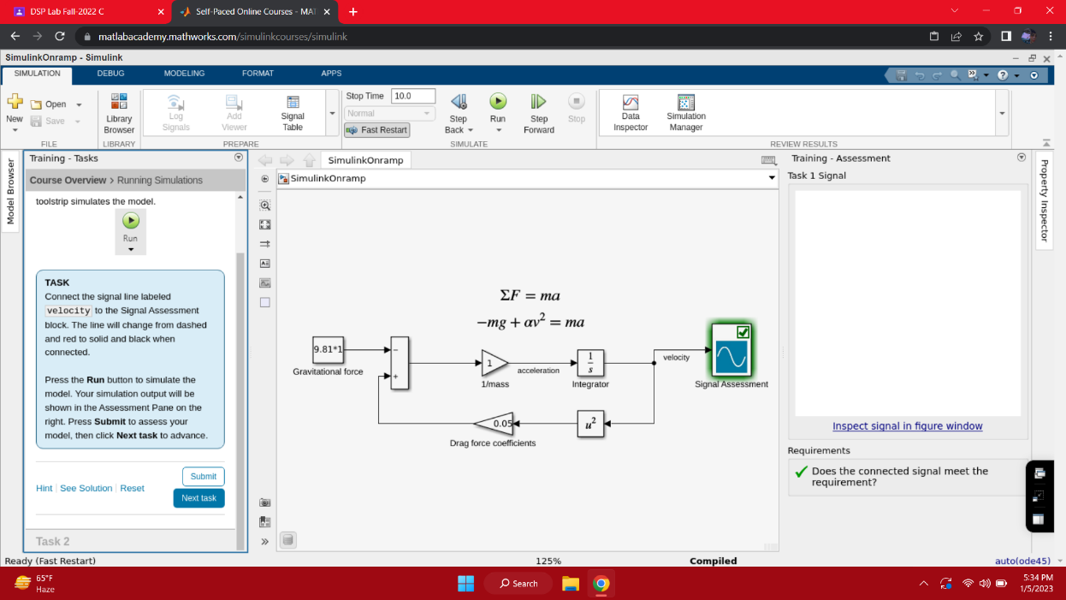

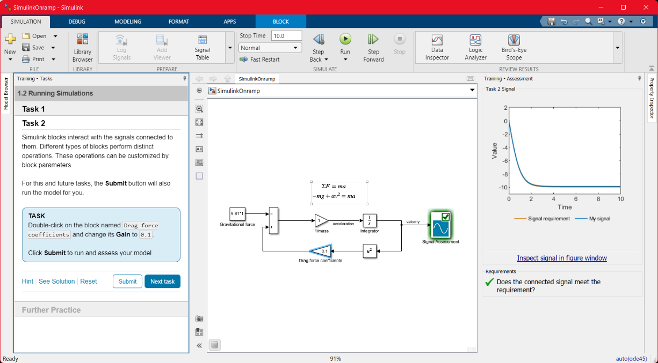

1. **Simulink Graphic Environment**

**a.** Learn about Simulink blocks and signals.

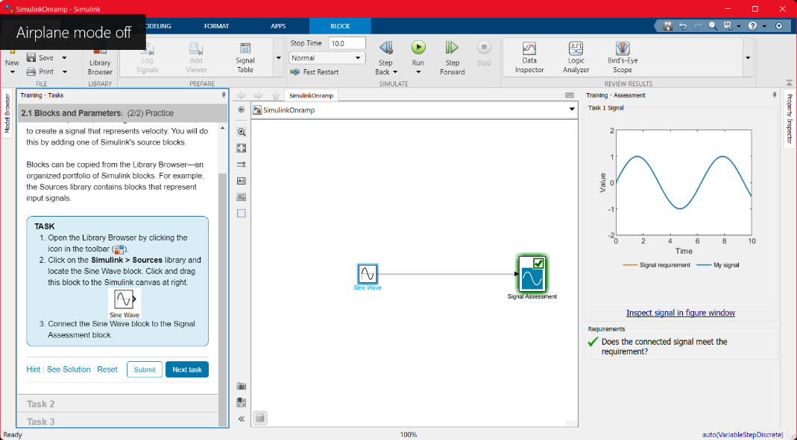

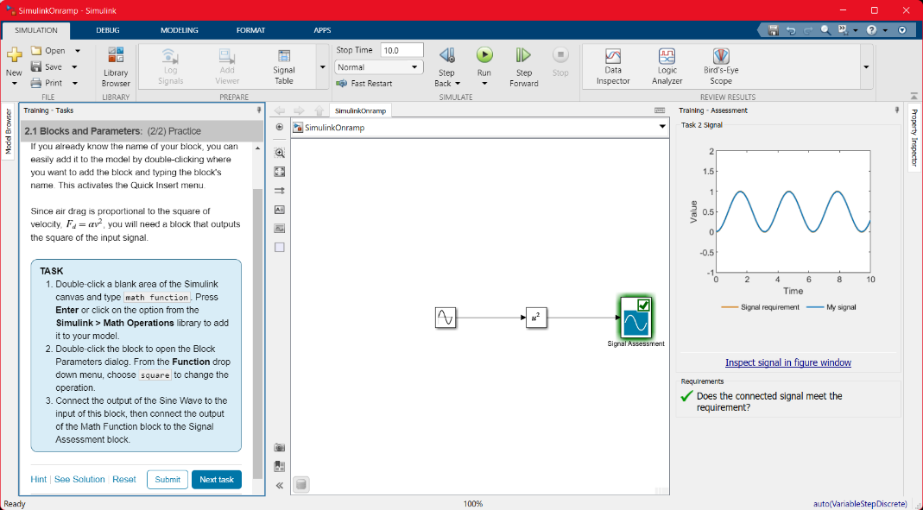

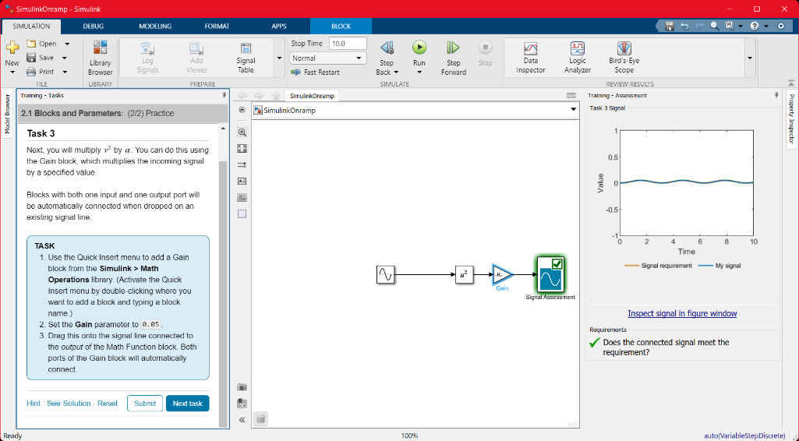

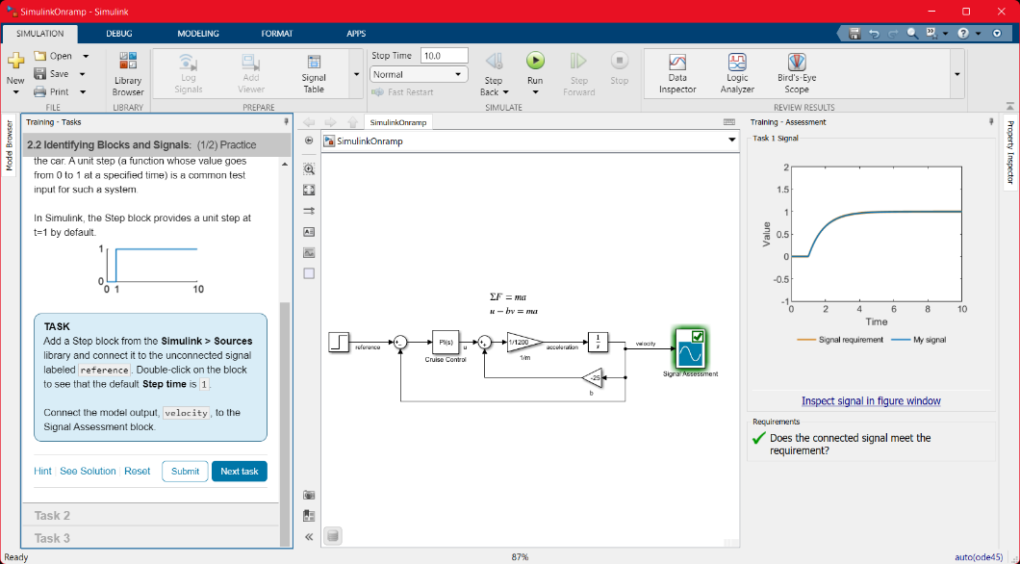

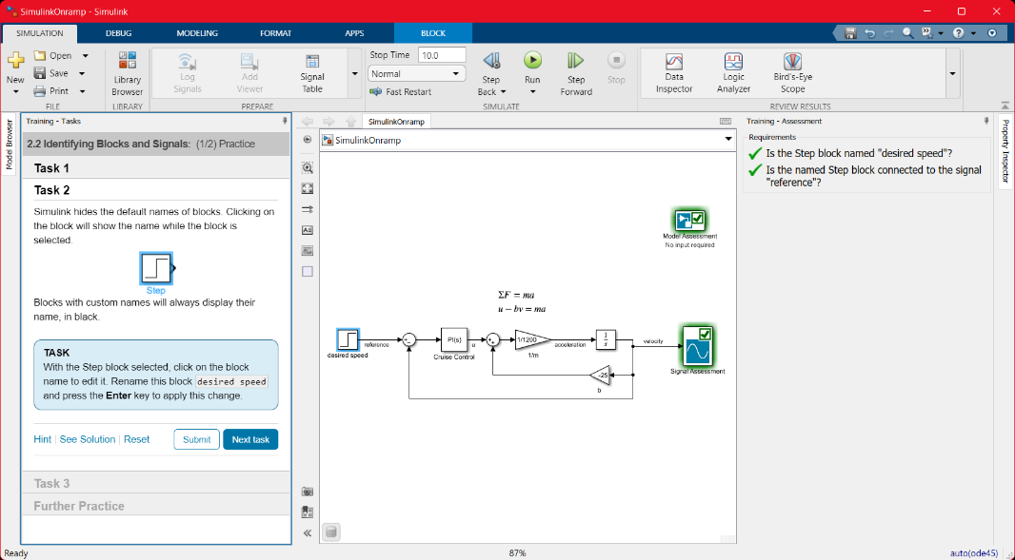

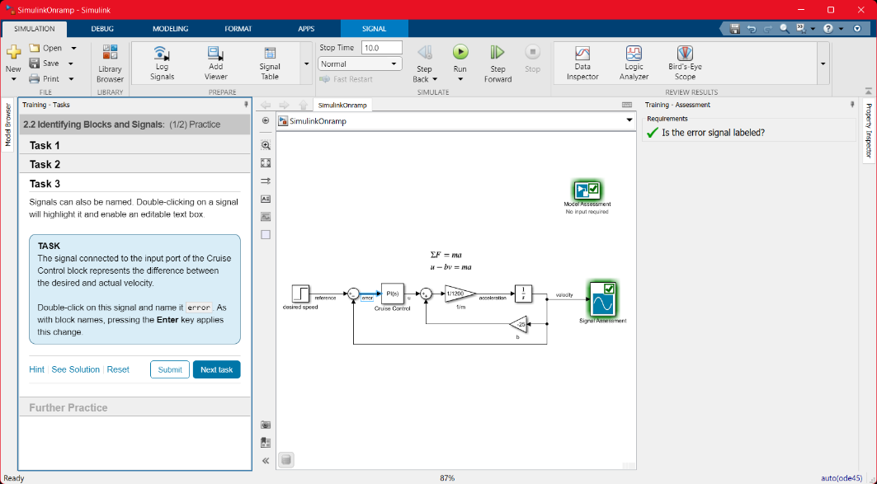

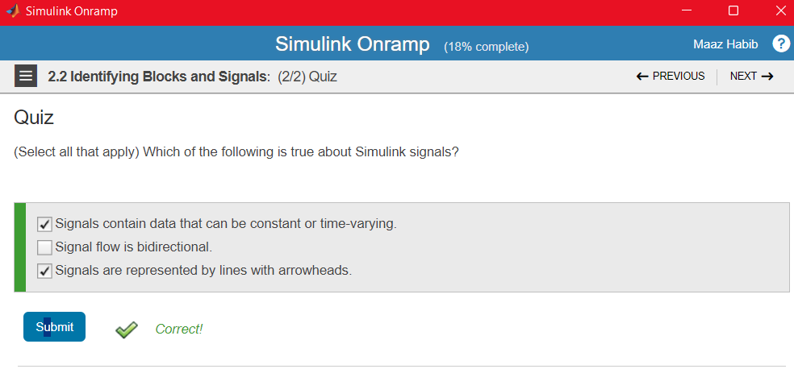

1. **Inspecting Signals**

**a.** Visualize signal values during simulation.

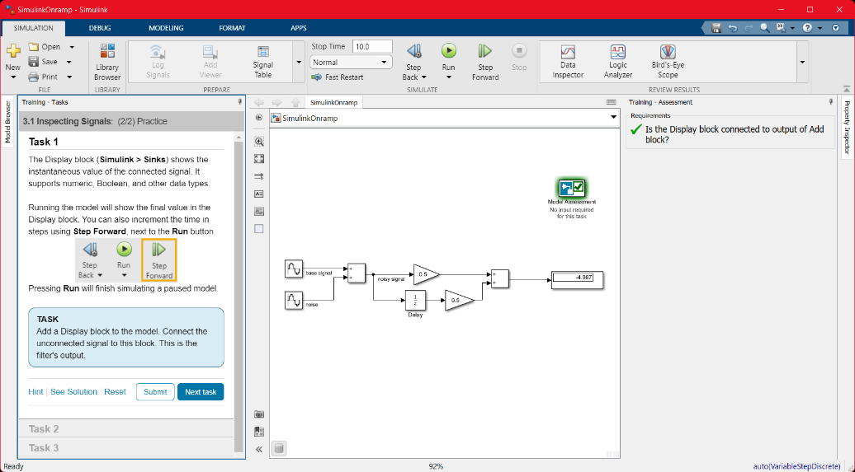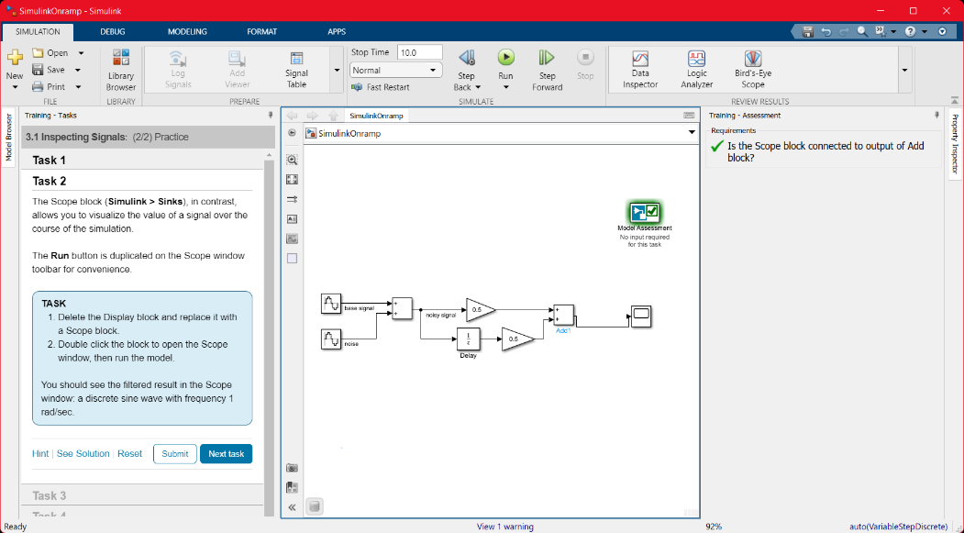

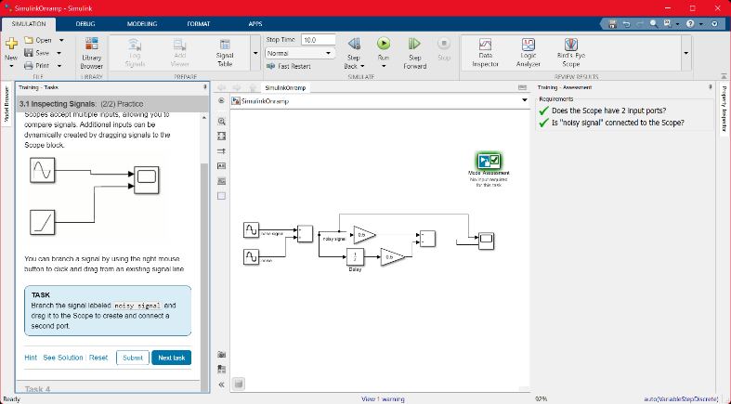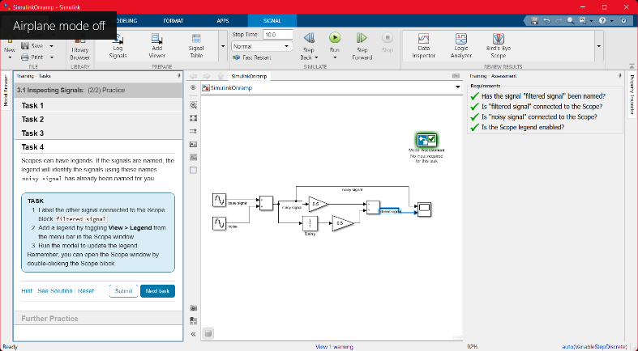

1. **Use Basic Algorithms**

**a.** Use math and logic operators to write algorithms.

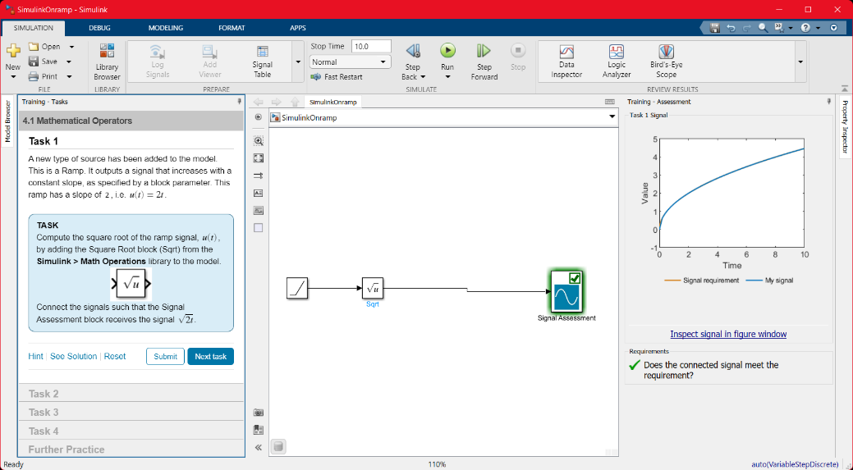

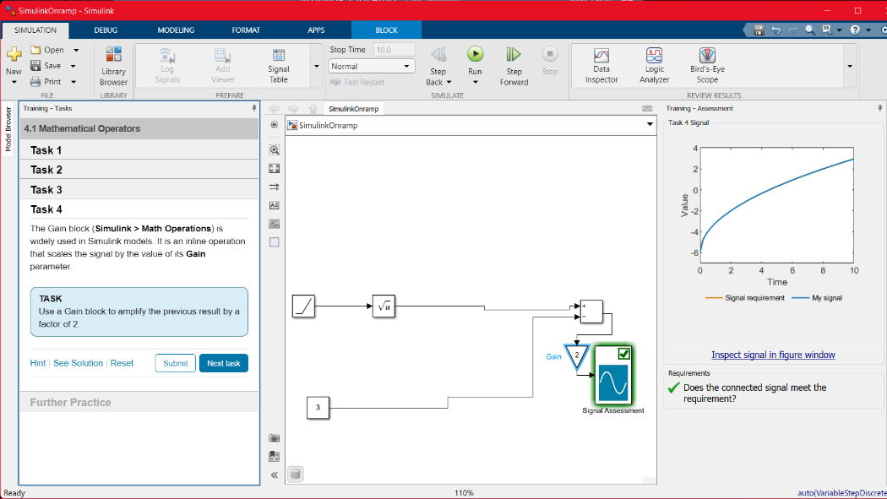

1. **Obtaining Help**

**a.** Access documentation from Simulink.

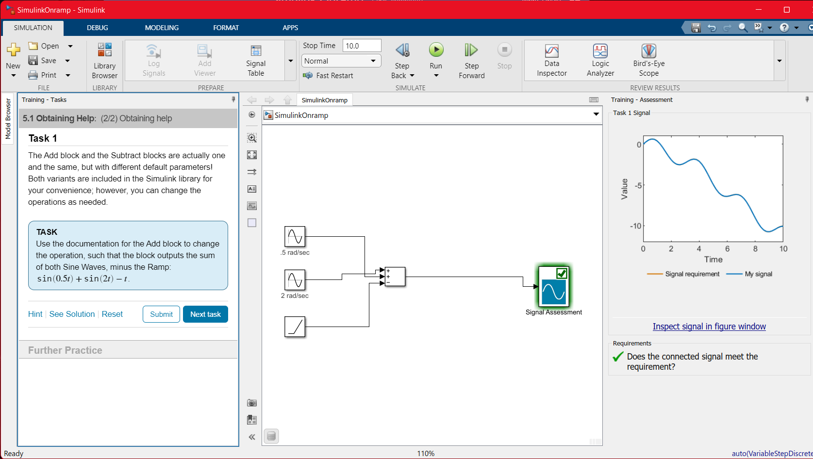

1. **Project- Automotive Performance Modes**

**a.** Practice working with math and logic operators.

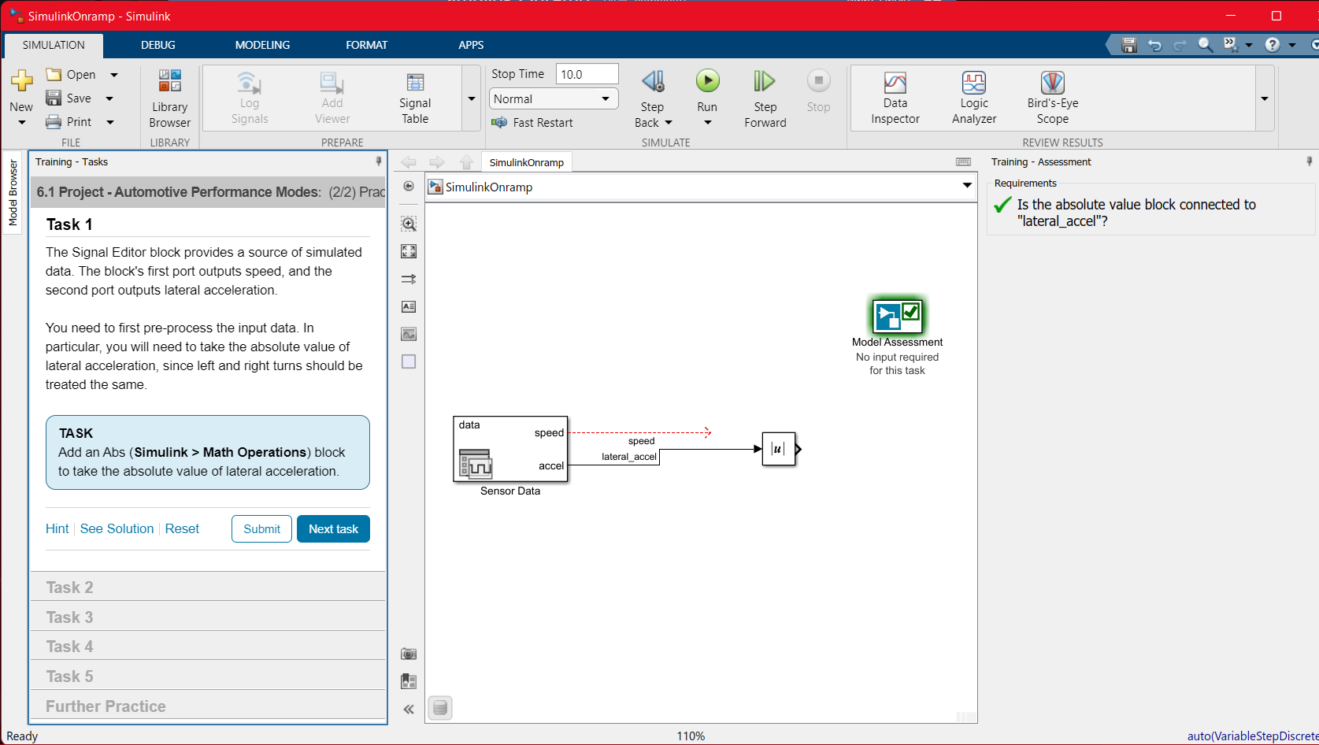

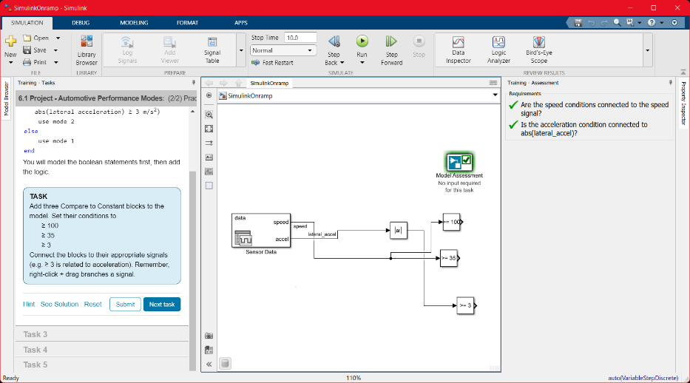

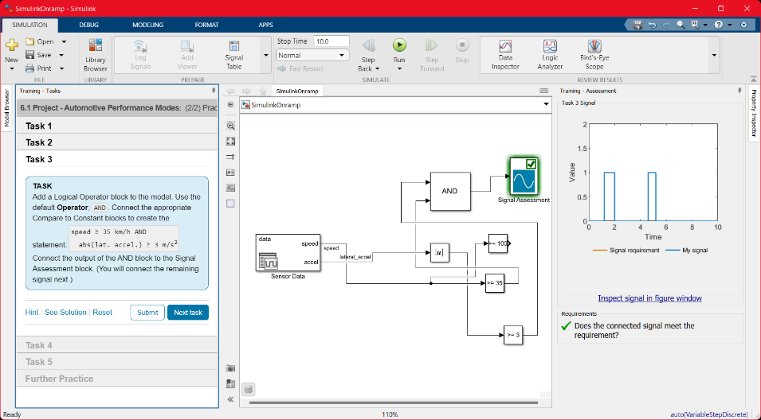

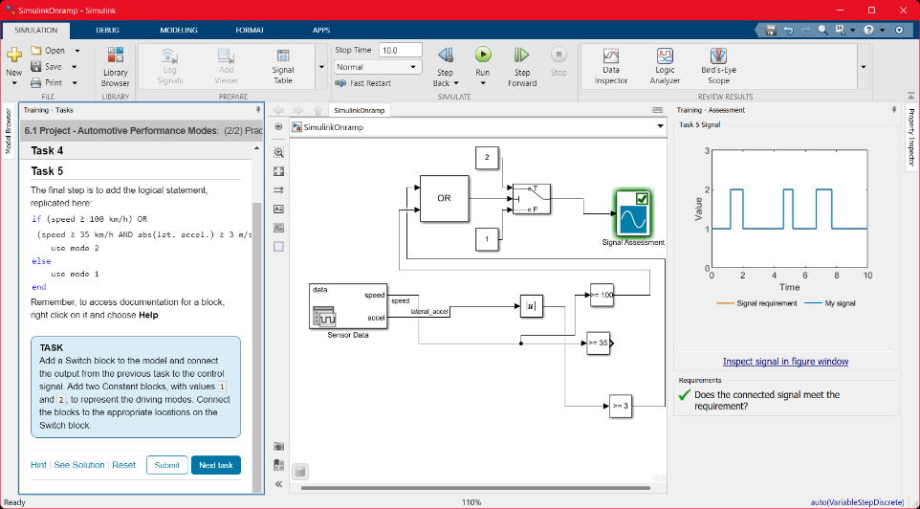

1. **Simulink and Matlab**

**a.** Use MATLAB variables and functions in Simulink.

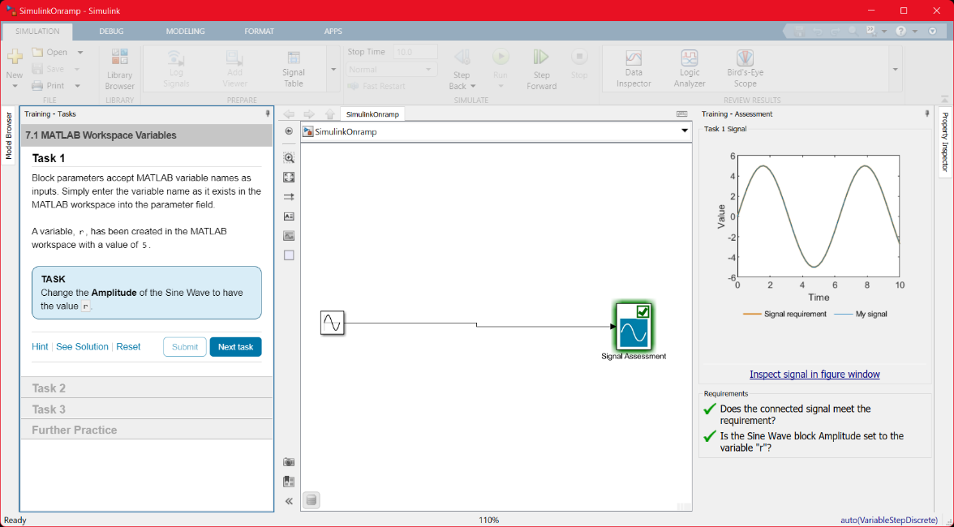

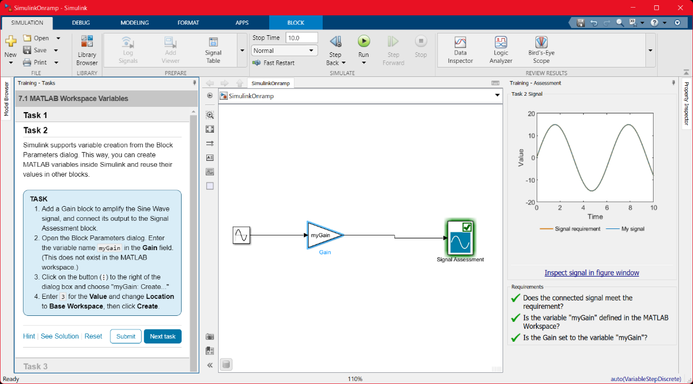

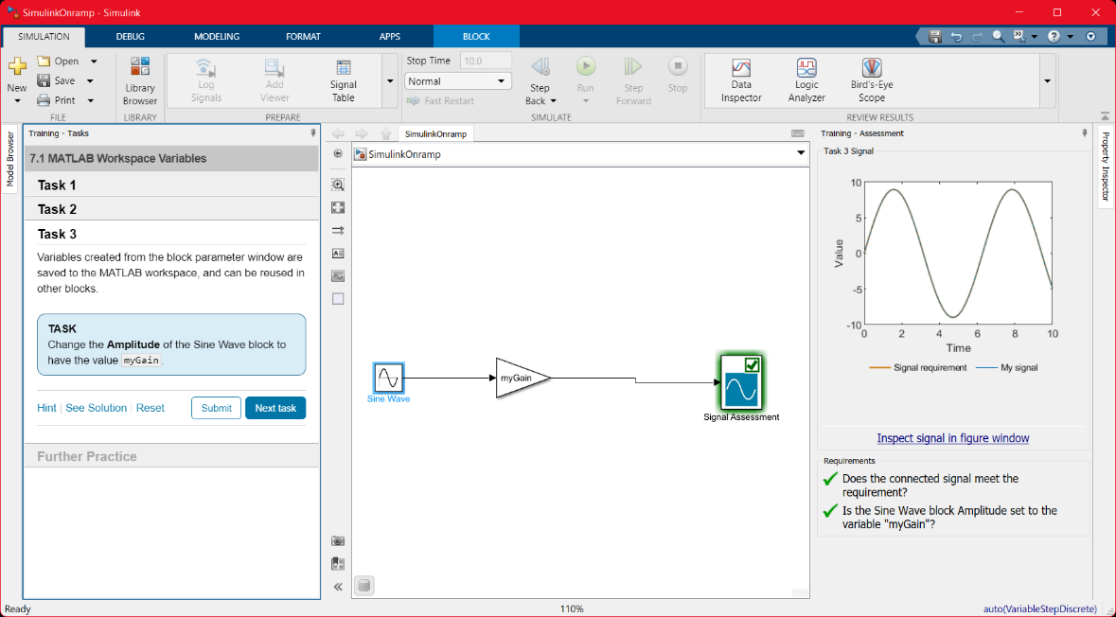

1. **Dynamic systems in Simulink**

**a.** Review dynamic systems and learn how they relate to Simulink.

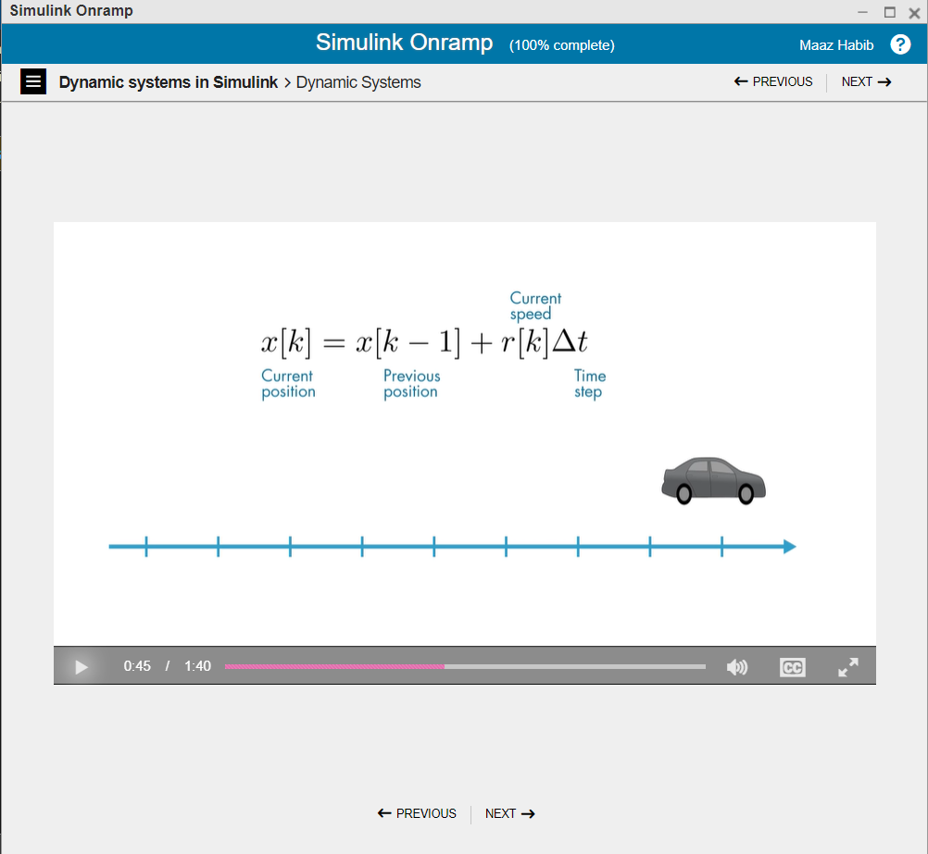

1. **Discrete Systems**

**a.** Model discrete-time systems.

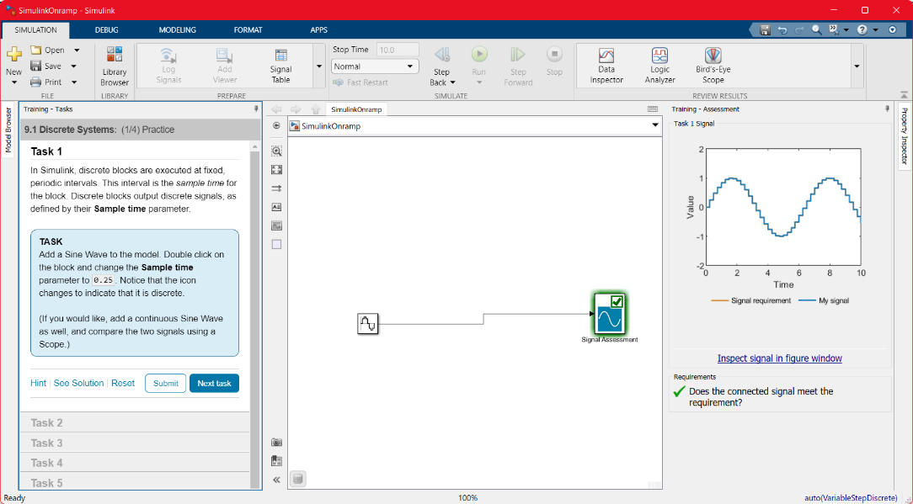

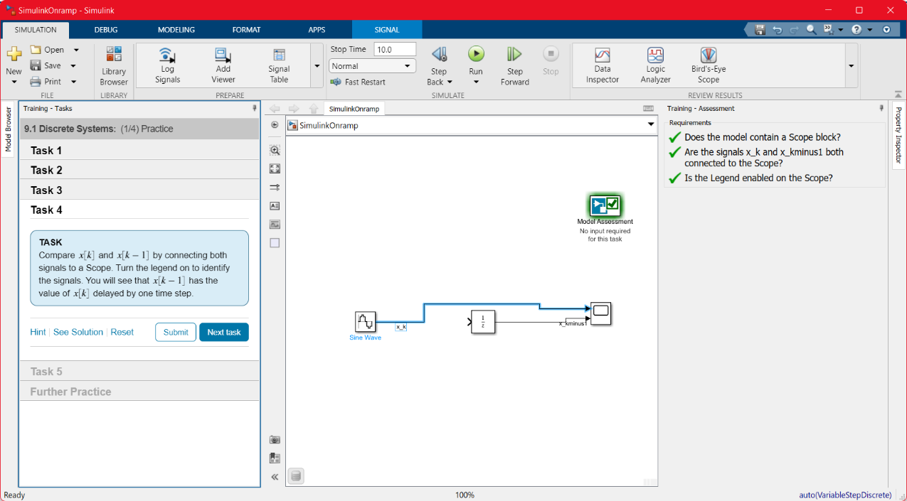

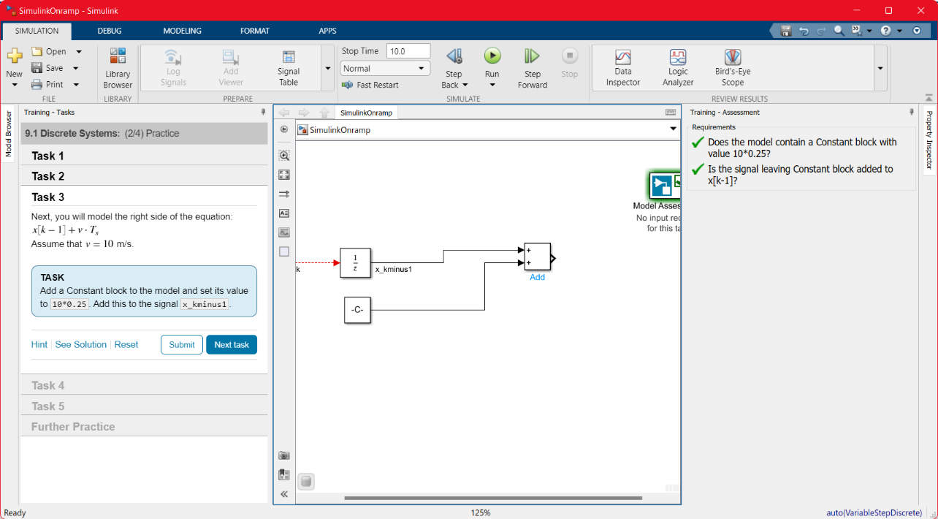

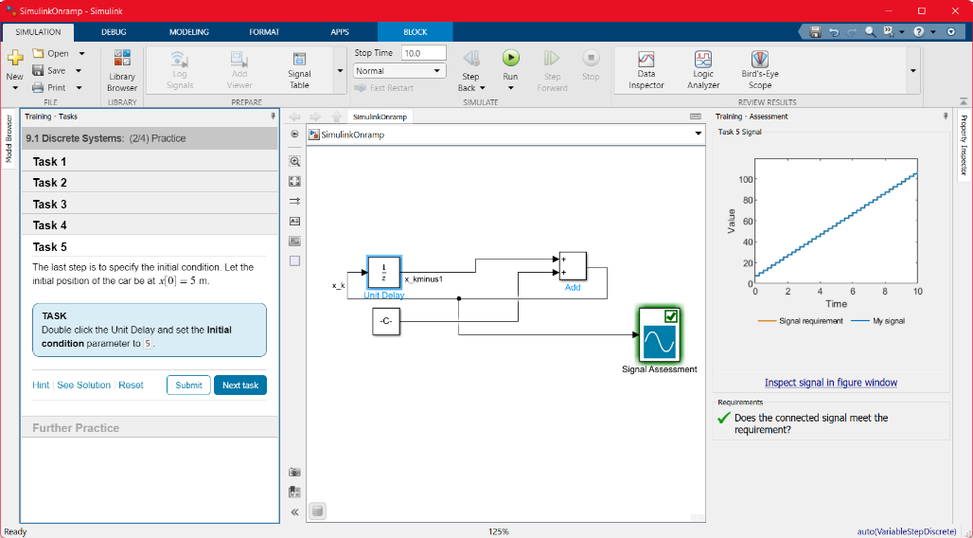

1. **Continuous Systems**

**a.** Model continuous-time systems

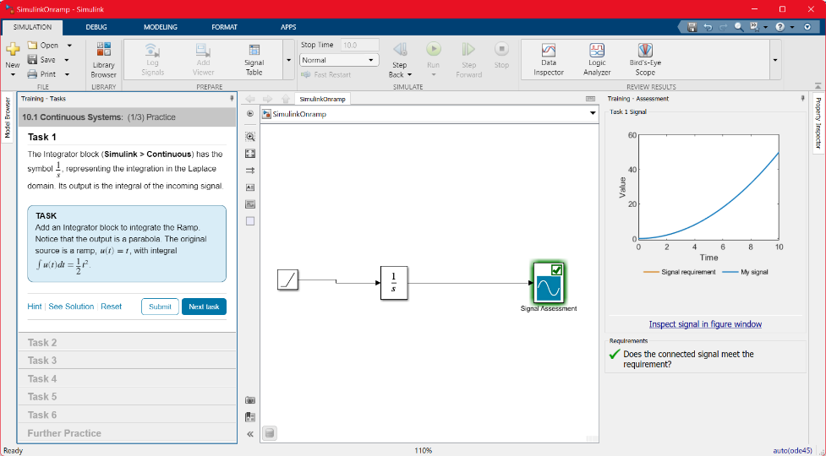

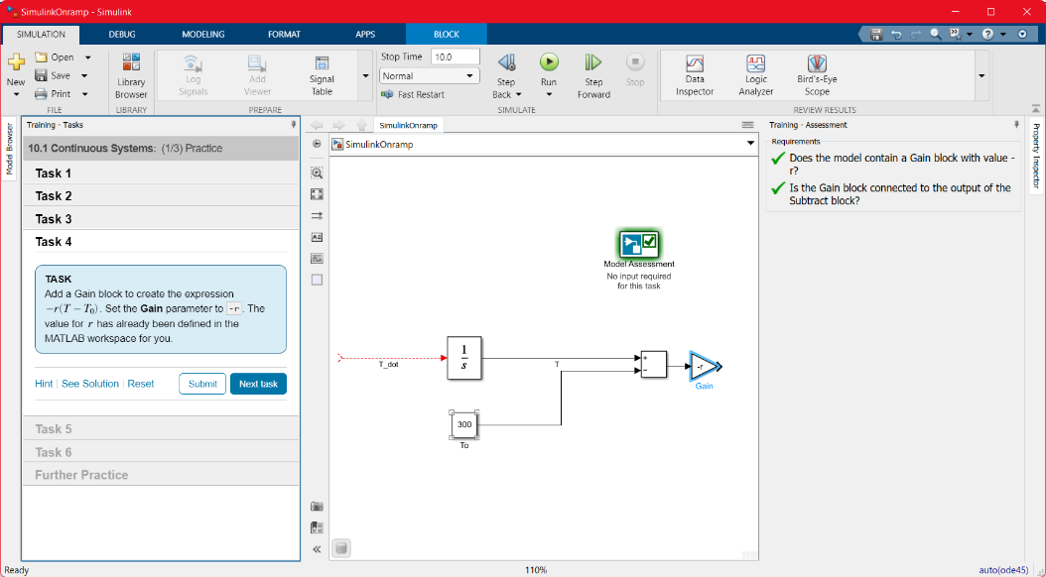

1. **Simulation Time**

**a.** Choose the simulation duration.

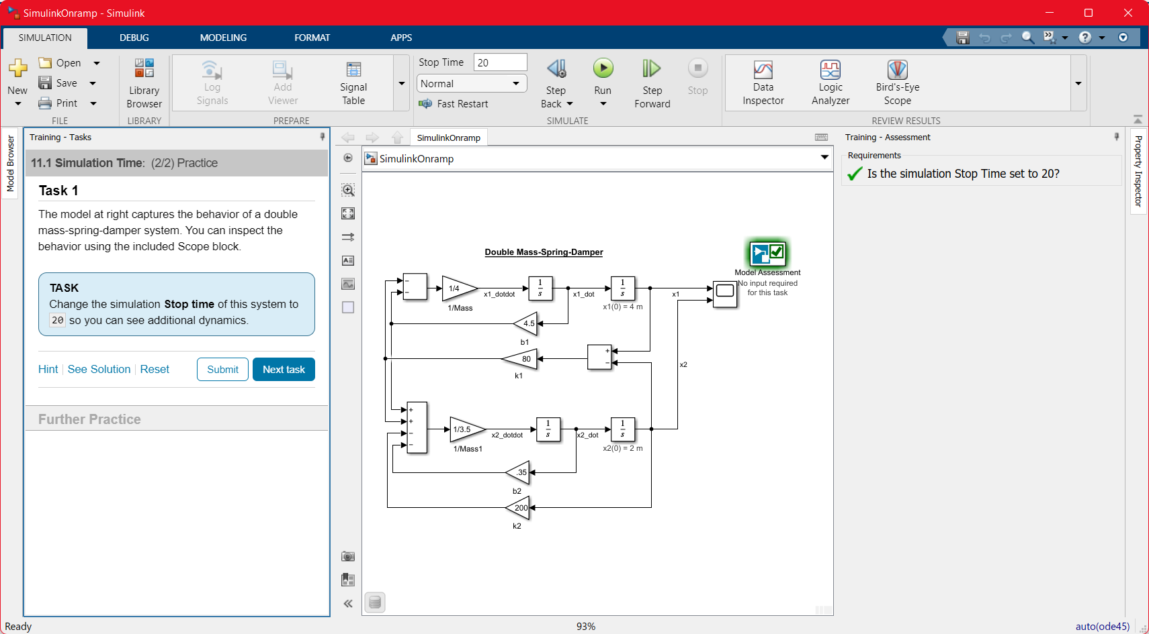

1. **Project- Modeling a Thermostat**

**a.** Practice your understanding of discrete dynamic systems.

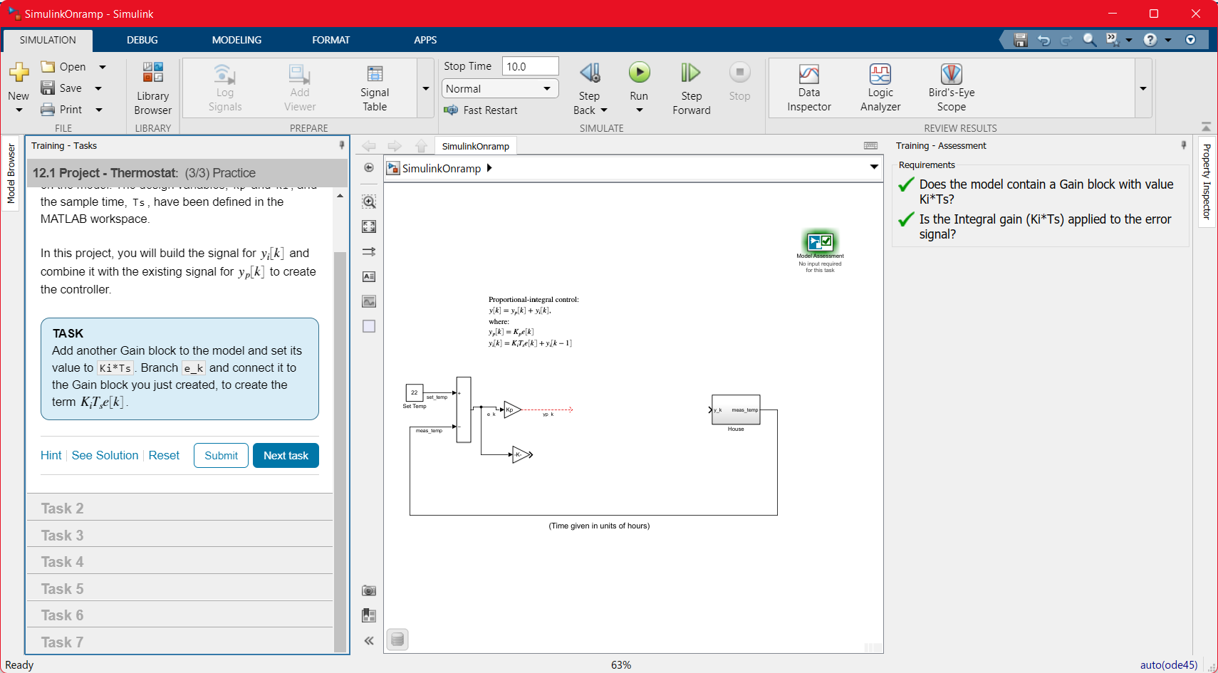

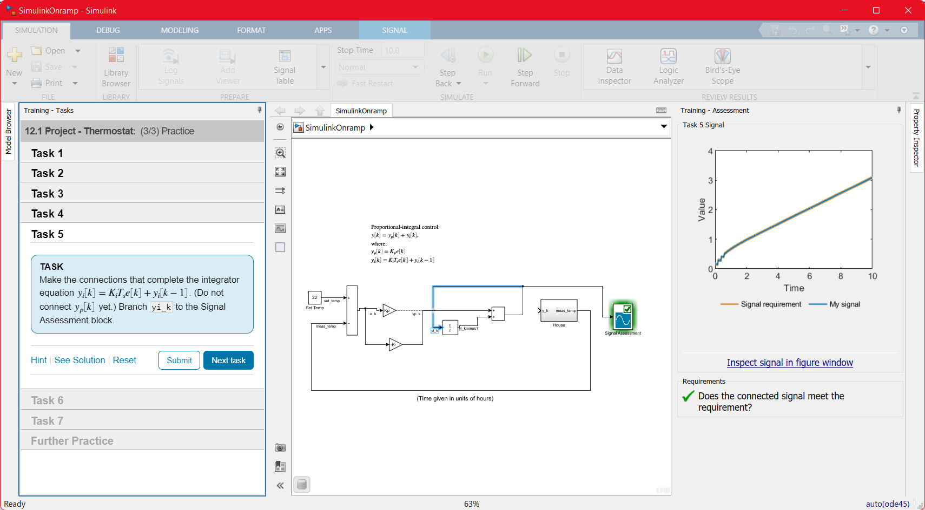

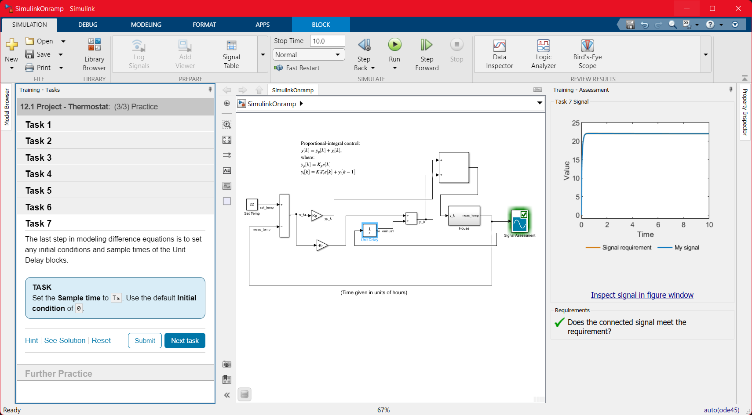

1. **Project – Peregrine Falcon Dive**

a. Practice your understanding of continuous dynamic systems.

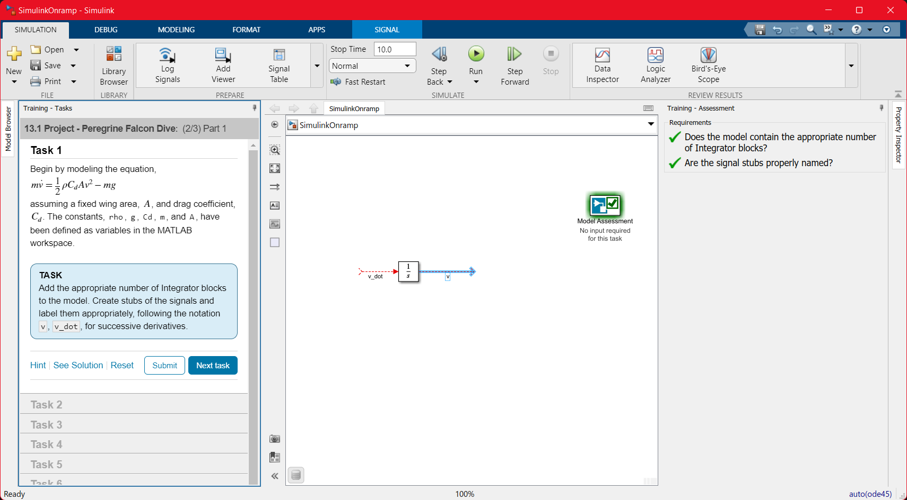

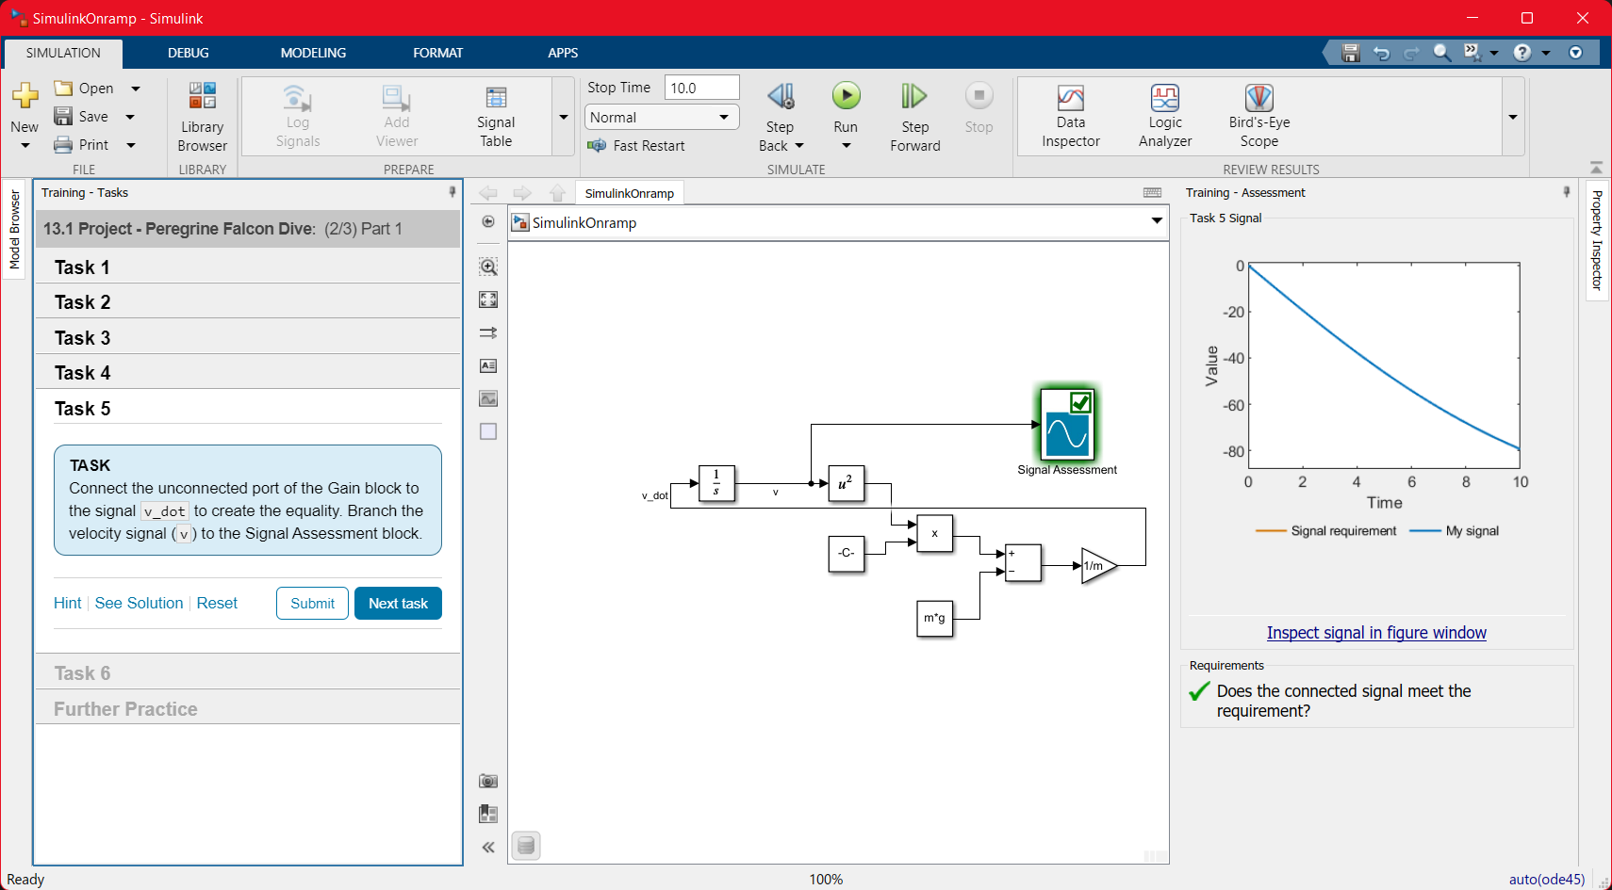

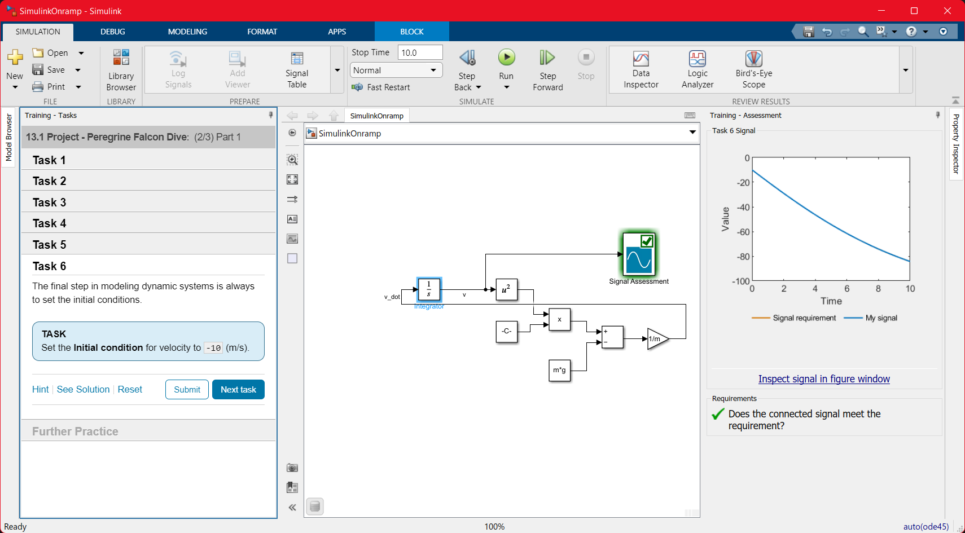

1. **Conclusions:**

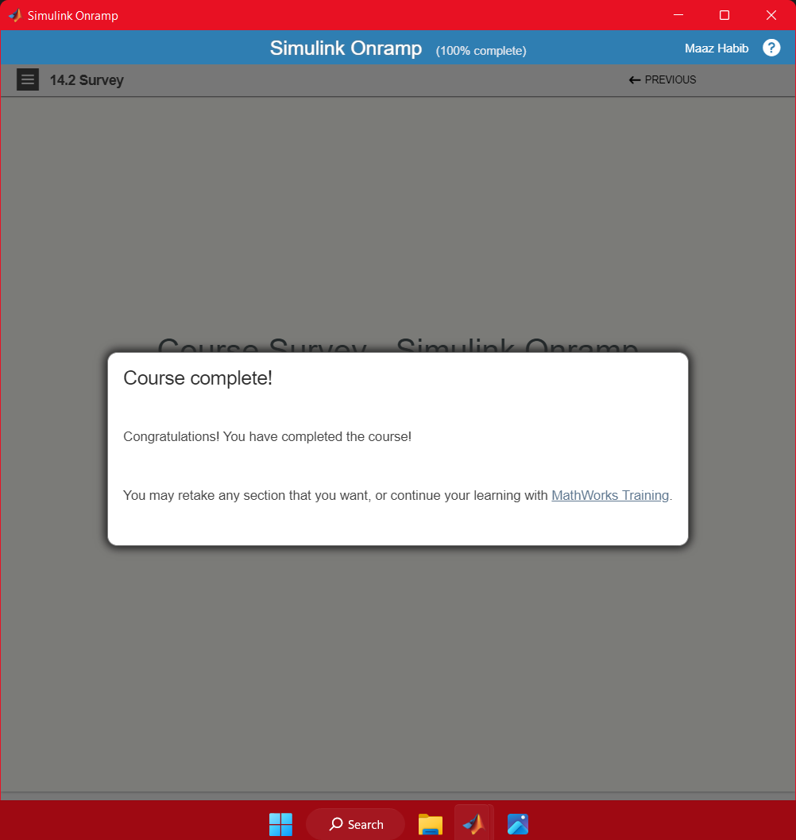

**Certificate:**

